Lesson 44
Reptiles: Evolutionary perspective
The earliest members of the class Reptilia (rep-tile-ah) (L. reptus, to creep) were the first vertebrates to possess amniotic eggs. Amniotic eggs have extraembryonic membranes that protect the embryo from desiccation, cushion the embryo, promote gas transfer, and store waste materials (figure 1). The amniotic eggs of reptiles and birds also have hard or leathery shells that protect the developing embryo, albumen that cushions and provides moisture and nutrients for the embryo, and yolk that supplies food to the embryo. All of these features are adaptations for development on land. (The amniotic egg is not, however, the only kind of land egg: some arthropods, amphibians, and even a few fishes have eggs that develop on land.) The amniotic egg is the major synapomorphy that distinguishes the reptiles, birds, and mammals from vertebrates in the nonamniote lineage.
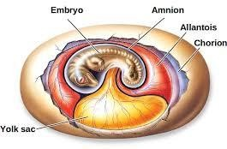
Even though the amniotic egg has played an important role in vertebrates’ successful invasion of terrestrial habitats, it is one of many reptilian adaptations that have allowed members of this class to flourish on land. Living representatives of the class Reptilia include the turtles, lizards, snakes, worm lizards, crocodilians, and the tuatara.
Figure 1
The Amniotic Egg. The amniotic egg provides a series of extraembryonic membranes that protect the embryo from desiccation. In reptiles, birds, and one group of mammals, the egg is enclosed within a shell (not shown). The embryo develops at the surface of a mass of yolk. The amnion encloses the embryo in a fluid-filled sac and protects against shock and desiccation. The chorion is nearer the shell and becomes highly vascular and aids in gas exchange. The allantois is a ventral outgrowth of the gut and stores nitrogenous wastes (e.g., uric acid).

Classes of reptiles according to opening in temporal region

- Anapsida
Reptiles in the subclass Anapsida (Gr. an, without hapsis, arch) lack openings or fenestrae in the temporal (posterolateral) region of the skull. The turtles represent this lineage today.
Evidence of the anapsid lineage has been found in 245-million-year-old rocks from South Africa.

Diapsid
A second group of reptiles are diapsid (Gr. di, two). They have upper and lower openings in the temporal region of the skull. Taxonomists divide this group into two subclasses. One subclass, the Lepidosauria, includes modern snakes, lizards, and tuataras. A second sub- class, Archosauria, underwent extensive evolutionary radiation in the Mesozoic era and includes the dinosaurs. Most archosaurs are now extinct. Living archosaurs include the crocodilians and the dinosaurs’ closest living relatives—the birds.

Synapsid
Another group of reptiles are synapsid (Gr. syn, with). They possess a single dorsal opening in the temporal region of the skull.
Although no reptilian descendants of this group survive today, they are important because a group of synapsids, called therapsids, gave rise to the mammals.
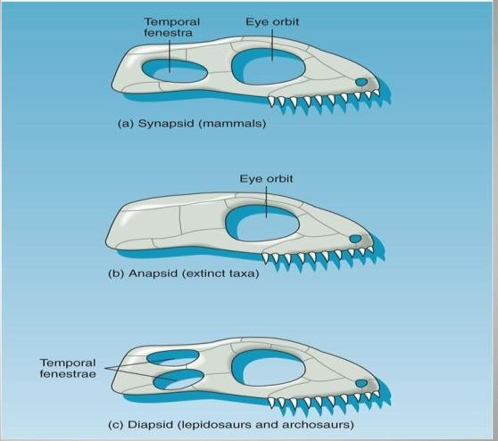
Figure 2: Amniotic skull characteristics

Cladistic interpretation of the amniotic lineage
Cladistic analysis shows that the birds (traditionally the class Aves) and the mammals (traditionally the class Mammalia) share a common ancestor with the reptiles.

Lesson 45
Survey of the reptiles

General characteristics of Reptiles
- They have dry skin with epidermal scales
- Skull with one point of articulation with the vertebral column (occipital condyle); respiration via
- Lungs are present in reptiles
- Osmoregulation occurs through metanephric kidneys
- internal fertilization
- Amniotic eggs
- They have four orders named as; 1. Testudines, 2. Rhynchocephalia 3. Squamata, 4. Crocodilia

Order testudines (Chelonia)
- Members of the order Testudines (tes-tudin-ez) (L. testudo, tortoise), or Chelonia (ki-lone- ah) (Gr. chelone, tortoise), are the turtles. The approximately 225 species of turtles are characterized by a bony shell, limbs articulating internally to the ribs, and a keratinized beak rather than teeth.
- The dorsal portion of the shell is the carapace, which forms from a fusion of vertebrae, expanded ribs, and bones in the dermis of the skin. Keratin covers the bone of the carapace.
- The ventral portion of the shell is the plastron. It forms from bones of the pectoral girdle and dermal bone, and keratin also covers it (figure 3).
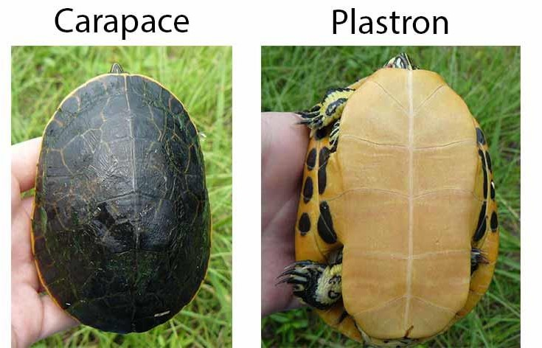
Figure 3

- In some turtles, such as the North American box turtle (Terrapene), the shell has flexible areas, or hinges, that allow the anterior and posterior edges of the plastron to be raised.
- Turtles have eight cervical vertebrae that can be articulated into an S-shaped configuration, which allows the head to be drawn into the shell.
- Turtles have long life spans. Most reach sexual maturity after seven or eight years, and live 14 or more years. Large tortoises of the Galápagos Islands may live in excess of 100 years
- All turtles are oviparous
- Females use their hindlimbs to excavate nests in the soil. There they lay and cover with soil clutches of 5 to 100 eggs.
- Development takes from four weeks to one year, and the parent does not attend to the eggs during this time. The young are independent of the parent at hatching.

Order rhynchocephalia
The one surviving species of the order Rhynchocephalia (rinko-se-fale-ah) (Gr. rhynchos, snout kephale, head) is the tuatara (Sphenodon punctatus) (figure 4). This superficially lizardlike reptile is virtually unchanged from extinct relatives that were present at the beginning of the Mesozoic era, nearly 200 million years ago. Tooth attachment and structure distinguish the tuatara from other reptiles. Two rows of teeth on the upper jaw and a single row of teeth in the lower jaw produce a shearing bite that can decapitate a small bird. Formerly more widely distributed in New Zealand, the tuatara fell prey to human influences and domestic animals. It is now present only on remote offshore islands and is protected by New Zealand law.
It is oviparous and shares under- ground burrows with ground-nesting seabirds. Tuataras venture out of their burrows at dusk and dawn to feed on insects or, occasionally, small vertebrates.
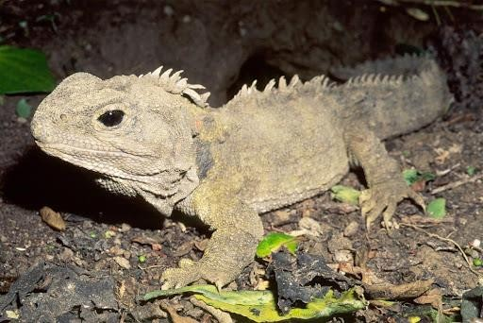
Figure 4

Lesson 46 Order squamata

The order Squamata (L. squama, scale + ata, to bear) is divided into three suborders.

Suborder Sauria—The Lizards
About 3,300 species of lizards are in the suborder Sauria (Gr. sauro, lizard). In contrast to snakes, lizards usually have two pairs of legs, and their upper and lower jaws unite anteriorly. Lizards vary in length from only a few centimeters to as large as 3 m. Many lizards live on surface substrates and retreat under rocks or logs when necessary. Others are burrowers or tree dwellers.
Most lizards are oviparous; some are ovoviviparous or viviparous. They usually deposit eggs under rocks or debris or in burrows. Geckos, commonly found on the walls of human dwellings in semitropical areas, are short and stout. They are nocturnal, and unlike most lizards, are capable of clicking vocalizations. Their large eyes, with pupils that contract to a narrow slit during the day and dilate widely at night, are adapted for night vision.
Adhesive disks on their digits aid in clinging to trees and walls. Iguanas have robust bodies, short necks, and distinct heads. This group includes the marine iguanas of the Galápagos Islands and the

flying dragons (Draco) of Southeast Asia. The latter have lateral folds of skin supported by ribs. Like the ribs of an umbrella, the ribs of Draco can expand to form a gliding surface. When this lizard launches itself from a tree, it can glide 30 m or more!
Another group of iguanas, the chameleons, lives mainly in Africa and India. Chameleons are adapted to arboreal lifestyles and use a long, sticky tongue to capture insects. Anolis, or the “pet- store chameleon,” is also an iguanid, but is not a true chameleon. Chameleons and Anolis are well known for their ability to change color in response to illumination, temperature, or their behavioral state.
The only venomous lizards are the gila monster (Heloderma suspectum) and the Mexican beaded lizard (Heloderma horridum). These heavy-bodied lizards are native to south-western North America. Venom is released into grooves on the surface of teeth and introduced into prey as the lizard chews. Lizard bites are seldom fatal to humans.

Suborder Serpentes—The Snakes
About 2,300 species are in the suborder Serpentes (ser-pentez) (L.serpere, to crawl). Although the vast majority of snakes are not dangerous to humans, about three hundred species are venomous. Snakes are elongate and lack limbs, although vestigial pelvic girdles and appendages are sometimes present. The skeleton may contain more than two hundred vertebrae and pairs of ribs. Joints between vertebrae make the body very flexible.
Snakes possess skull adaptations that facilitate swallowing large prey. These adaptations include upper jaws that are movable on the skull, and upper and lower jaws that are loosely joined so that each half of the jaw can move independently.
Other differences between lizards and snakes include the mechanism for focusing the eyes and the morphology of the retina. Elongation and narrowing of the body has resulted in the reduction or loss of the left lung and displacement of the gallbladder, the right kidney, and often, the gonads. Most snakes are oviparous, although a few, such as the New World boas and garter snakes, give birth to live young.

Suborder Amphisbaenia—Worm-Lizards
About 135 species are in the suborder Amphisbaenia (Gr. amphi, double + baen, to walk). They are specialized burrowers that live in soils of Africa, South America, the Caribbean, and the Mideast. Most are legless, and their skulls are wedge or shovel shaped. A single median tooth in the upper jaw distinguishes amphisbaenians from all other vertebrates. The skin of amphisbaenians has ringlike folds called annuli and loosely attaches to the body wall. Muscles of the skin cause it to telescope and bulge outward, forming an anchor against a burrow wall. Amphisbaenians move easily forward or backward—thus, the suborder name. They feed on worms and small insects and are oviparous.

Lesson 47
Order crocodilian
The order Crocodilia (Gr. krokodeilos, lizard) has 21 species. Along with dinosaurs, crocodilians are derived from the archosaurs and distinguished from other reptiles by certain skull characteristics: openings in the skull in front of the eye, triangular rather than circular eye orbits, and laterally compressed teeth. Living crocodilians include the alligators, crocodiles, gavials, and caimans. Crocodilians have not changed much over their 170 million-year history. The snout is elongate and often used to capture food by a sideways sweep of the head. The nostrils are at the tips of the snout, so the animal can breathe while mostly submerged. Air passageways of the head lead to the rear of the mouth and throat, and a flap of tissue near the back of the tongue forms a watertight seal that allows breathing without inhaling water in the mouth.
A plate of bone, called the secondary palate, evolved in the archosaurs and separates the nasal and mouth passage ways. The muscular, elongate, and laterally compressed tail is used for swimming, offensive and defensive maneuvers, and attacking prey. Teeth are used only for seizing prey. Food is swallowed whole, but if a prey item is too large, crocodilians tear it apart by holding onto a limb and rotating their bodies wildly until the prey is dismembered. The stomach is gizzardlike, and crocodilians swallow rocks and other objects as abrasives for breaking apart ingested food. Crocodilians are oviparous and display parental care of hatchlings that parallels that of birds. Nesting behavior and parental care may be traced back to the common ancestor of both groups.
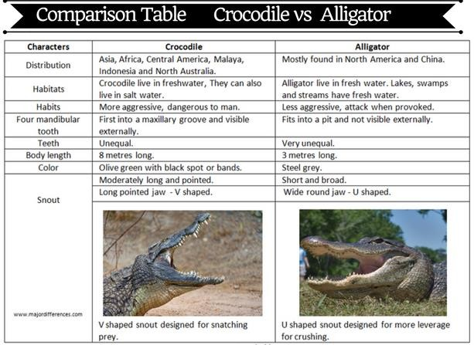

Lesson 48 Evolutionary pressures
The lifestyles of most reptiles reveal striking adaptations for terres-trialism. For example, a lizard common to deserts of the southwestern United States––the chuckwalla (Sauromalus obesus)— survives during late summer when temperatures exceed 40° C (104° F) and when arid conditions wither plants and blossoms upon which chuckwallas browse (figure 20.10). To withstand these hot and dry conditions, chuckwallas disappear below ground and aestivate. Temperatures moderate during the winter, but little rain falls, so life on the desert surface is still not possible for the chuckwalla. The summer’s sleep, therefore, merges into a winter’s sleep. The chuckwalla does not emerge until March, when rain falls, and the desert explodes with greenery and flowers. The chuckwalla browses and drinks, storing water in large reservoirs under its skin. Chuck-wallas are not easy prey. If threatened, a chuckwalla takes refuge in the nearest rock crevice. There, it inflates its lungs with air, increasing its girth and wedging itself against the rock walls of its refuge. Friction of its body scales against the rocks makes the chuckwalla nearly impossible to dislodge. The adaptations that chuckwallas display are not exceptional for reptiles. This section discusses some of these adaptations that make life apart from an abundant water supply possible.

EXTERNAL STRUCTURE AND LOCOMOTION
External structures
Unlike that of amphibians, the skin of reptiles has no respiratory functions. Reptilian skin is thick, dry, and keratinized. Scales may be modified for various functions. For example, the large belly scales of snakes provide contact with the substrate during locomotion. Although reptilian skin is much less glandular than that of amphibians, secretions include pheromones that function in sex recognition and defense. All reptiles periodically shed the outer, epidermal layers of the skin in a process called ecdysis. Because the blood supply to the skin does not extend into the epidermis, the outer epidermal cells lose contact with the blood supply and die. Movement of lymph between the inner and outer epidermal layers loosens the outer epidermis. Ecdysis generally begins in the head region, and in snakes and many lizards, the epidermal layers come off in one piece. In other lizards, smaller pieces of skin flake off. The frequency of ecdysis varies from one species to another, and it is greater in juveniles than adults. Cryptic coloration, mimicry, and aposematic coloration occur in reptiles. Color and color change also function in sex recognition and thermoregulation.

Support and Movement
The skeletons of snakes, amphisbaenians, and turtles show modifications; however, in its general form, the reptilian skeleton is based on one inherited from ancient amphibians. The skeleton is highly ossified to provide greater support. The skull is longer than that of amphibians, and a plate of bone, the secondary palate, partially separates the nasal passages from the mouth cavity. Longer snouts also permit greater development of olfactory epithelium and increased reliance on the sense of smell. Reptiles have more cervical vertebrae than do amphibians. The first two cervical vertebrae (atlas and axis) provide greater freedom of movement for the head. An atlas articulates
with a single condyle on the skull and facilitates nodding. An axis is modified for rotational movements. A variable number of other cervical vertebrae provide additional neck flexibility. The ribs of reptiles may be highly modified. Those of turtles and the flying dragon were described previously. The ribs of snakes have muscular connections to large belly scales to aid locomotion. The cervical vertebrae of cobras have ribs that may be flared in aggressive displays. Two or more sacral vertebrae attach the pelvic girdle to the vertebral column. The caudal vertebrae of many lizards possess a vertical fracture plane. When a lizard is grasped by the tail, caudal vertebrae can be broken, and a portion of the tail is lost. Tail loss, or autotomy, is an adaptation that allows a lizard to escape from a predator’s grasp, or the disconnected, wiggling piece of tail may distract a predator from the lizard. The lizard later regenerates the lost portion of the tail. Locomotion in primitive reptiles is similar to that of salamanders. The body is slung low between paired, stocky appendages, which extend laterally and move in the horizontal plane. The limbs of other reptiles are more elongate and slender, and are held closer to the body. The knee and elbow joints rotate posteriorly; thus, the body is higher off the ground, and weight is supported vertically. Many prehistoric reptiles were bipedal, meaning that they walked on hindlimbs. They had a narrow pelvis and a heavy, outstretched tail for balance. Bipedal locomotion freed the front appendages, which became adapted for prey cap- ture or flight in some animals.

Lesson 49
NUTRITION AND THE DIGESTIVE SYSTEM, CIRCULATION, GAS EXCHANGE, AND TEMPERATURE REGULATION

Nutrition and the digestive system
Most reptiles are carnivores, although turtles will eat almost anything organic. The tongues of turtles and crocodilians are non-protrusible and aid in swallowing. Like some anurans, some lizards and the tuatara have sticky tongues for capturing prey. The tongue extension of chameleons exceeds their body length. Probably the most remarkable adaptations of snakes involve modifications of the skull for feeding. The bones of the skull and jaws loosely join and may spread apart to ingest prey much larger than a snake’s normal head size. The bones of the upper jaw are movable on the skull, and ligaments loosely join the halves of both of the upper and lower jaws anteriorly. Therefore, each half of the upper and lower jaws can move independently of one another. After a prey is captured, opposite sides of the upper and lower jaws are alternately thrust forward and retracted. Posteriorly pointing teeth prevent prey escape and help force the food into the esophagus. The glottis, the respiratory opening, is far forward so that the snake can breathe while slowly swallowing its prey. Vipers (family Viperidae) possess hollow fangs on the maxillary bone at the anterior margin of the upper jaw. These fangs connect to venom glands that inject venom when the viper bites. The maxillary bone (upper jaw bone) of vipers is hinged so that when the snake’s mouth is closed, the fangs fold back and lie along the upper jaw. When the mouth opens, the maxillary bone rotates and causes the fangs to swing down. Because the fangs project outward from the mouth, vipers may strike at objects of any size. Rear-fanged snakes (family Colubridae) possess grooved rear teeth. In those that are venomous, venom is channeled along these grooves and worked into prey to quiet them during swallowing. These snakes usually do not strike, and most are harm to humans; however, the African boomslang (Dispholidustypus) has
caused human fatalities. Coral snakes, sea snakes, and cobras have fangs that rigidly attach to the upper jaw in an erect position. When the mouth is closed, the fangs fit into a pocket in the outer gum of the lower jaw. Fangs are grooved or hollow, and contraction of muscles associated with venom glands injects venom into the fangs. Some cobras can “spit” venom at their prey; if not washed from the eyes, the venom may cause blindness.
Venom glands are modified salivary glands. Most snake venoms are mixtures of neurotoxins and hemotoxins. The venoms of coral snakes, cobras, and sea snakes are primarily neurotoxins that attack nerve centers and cause respiratory paralysis. The venoms of vipers are primarily hemotoxins. They break up blood cells and attack blood vessel linings.

Circulation
The circulatory system of reptiles is based on that of amphibians. Because reptiles are, on average, larger than amphibians, their blood must travel under higher pressures to reach distant body parts. To take an extreme example, the blood of the dinosaur Brachiosaurus had to be pumped a distance of about 6 m from the heart to the head––mostly uphill! (The blood pressure of a giraffe is about double that of a human to move blood the 2 m from heart to head.) Like amphibians, reptiles possess two atria that are completely separated in the adult and have veins from the body and lungs emptying into them. Except for turtles, the sinus venosus is no longer a chamber but has become a patch of cells that acts as a pacemaker. The ventricle of most reptiles is incompletely divided (figure 5). (Only in crocodilians is the ventricular septum complete.)
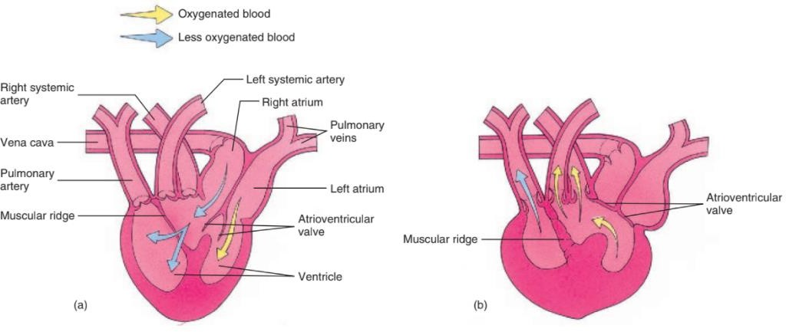
Figure 5: Heart and Major Arteries of a Lizard. (a) When the atria contract, blood enters the ventricle. An atrioventricular valve prevents the mixing of oxy-genated and less oxygenated blood across the incompletely separated ventricle. (b) When the ventricle contracts, a muscular ridge closes to direct oxygenated blood to the systemic arteries and less oxygenated blood to the pulmonary artery.
The ventral aorta and the conus arteriosus divide during development and become three major arteries that leave the heart. A pulmonary artery leaves the ventral side of the ventricle and takes blood to the lungs. Two systemic arteries, one from the ventral side of the heart and the other from the dorsal side of the heart, take blood to the lower body and the head. Blood low in oxygen enters the ventricle from the right atrium and leaves the heart through the pulmonary artery and moves to the lungs. Blood high in oxygen enters the ventricle from the lungs via pulmonary veins and the left atrium, and leaves the heart through left and right systemic arteries. The incomplete separation of the ventricle permits shunting of some blood away from the pulmonary circuit to the systemic circuit by constriction of muscles associated with the pulmonary artery. This is advantageous because virtually all reptiles breathe intermittently. When turtles withdraw into their shells, their method of lung ventilation cannot function. They also stop breathing during diving. During periods of apnea (“no breathing”), blood flow to the lungs is limited, which conserves energy and permits more efficient use of the pulmonary oxygen supply.

Gas Exchange
Reptiles exchange respiratory gases across internal respiratory surfaces to avoid losing large quantities of water. A larynx is present; however, vocal cords are usually absent. Cartilages support the respiratory passages of reptiles, and lungs are partitioned into sponge like, interconnected chambers. Lung chambers provide a large surface area for gas exchange.
In most reptiles, a negative-pressure mechanism is responsible for lung ventilation. A posterior movement of the ribs and the body wall expands the body cavity, decreasing pressure in the lungs and drawing air into the lungs. Air is expelled by elastic recoil of the lungs and forward movements of the ribs and body wall, which compress the lungs. The ribs of turtles are a part of their shell; thus, movements of the body wall to which the ribs attach are impossible. Turtles exhale by contracting muscles that force the viscera upward, compressing the lungs. They inhale by contracting muscles that increase the volume of the visceral cavity, creating negative pressure to draw air into the lungs.

Temperature Regulation
Unlike aquatic animals, terrestrial animals may face temperature extremes (65 to 70° C) that are incompatible with life. Temperature regulation, therefore, is important for animals that spend their entire lives out of water. Most reptiles use external heat sources for thermoregulation and are, therefore, ectotherms. Exceptions include monitor lizards and brooding Indian pythons. Female pythons coil around their eggs and elevate their body temperature as much as 7.3° C above the air temperature using metabolic heat sources. Some reptiles can survive wide temperature fluctuations (e.g., 2 to 41° C for some turtles). To sustain activity, however, body temperatures are regulated within a narrow range, between 25 and 37° C. If that is not possible, the reptile usually seeks a retreat where body temperatures are likely to remain within the range compatible with life.
Most thermoregulatory activities of reptiles are behavioral, and they are best known in the lizards. To warm itself, a lizard orients itself at right angles to the sun’s rays, often on a surface inclined toward the sun, and presses its body tightly to a warm surface to absorb heat by conduction. To cool itself, a lizard orients its body parallel to the sun’s rays, seeks shade or burrows, or assumes
an erect posture (legs extended and tail arched) to reduce conduction from warm surfaces. In hot climates, many reptiles are nocturnal.
Various physiological mechanisms also regulate body temperature. As temperatures rise, some reptiles begin panting, which releases heat through evaporative cooling. (Little evaporative cooling occurs across the dry skin of reptiles.) Marine iguanas divert blood to the skin while basking in the sun and warm up quickly. On diving into the cool ocean, however, marine iguanas reduce heart rate and blood flow to the skin, which slows heat loss. Chromatophores also aid in temperature regulation. Dispersed chromatophores (thus, a darker body) increase the rate of heat absorption.
In temperate regions, many reptiles withstand cold winter temperatures by entering torpor when body temperatures and metabolic rates decrease. Individuals that are usually solitary may migrate to a common site to spend the winter. Heat loss from these groups, called hibernacula, is reduced because the total surface area of many individuals clumped together is reduced compared to widely separated animals. Unlike true hibernators, the body temperatures of reptiles in torpor are not regulated, and if the winter is too cold or the retreat is too exposed, the animals can freeze and die. Death from freezing is an important cause of mortality for temperate reptiles.

Lesson 50
NERVOUS AND SENSORY FUNCTIONS
The brain of reptiles is similar to the brains of other vertebrates. The cerebral hemispheres are somewhat larger than those of amphibians. This increased size is associated with an improved sense of smell. The optic lobes and the cerebellum are also enlarged, which reflects increased reliance on vision and more refined coordination of muscle functions. The complexity of reptilian sensory systems is evidenced by a chameleon’s method of feeding. Its protruding eyes swivel independently, and each has a different field of view. Initially, the brain keeps both images separate, but when an insect is spotted, both eyes converge on the prey. Binocular vision then provides the depth perception for determining whether or not the insect is within range of the chameleon’s tongue. Vision is the dominant sense in most reptiles, and their eyes are similar to those of amphibians. Snakes focus on nearby objects by moving the lens forward. Contraction of the iris places pressure on the gel-like vitreous body in the posterior region of the eye, and displacement of this gel pushes the lens forward. All other reptiles focus on nearby objects when the normally elliptical lens is made more spherical, as a result of ciliary muscles pressing the ciliary body against the lens.
Reptiles have a greater number of cones than do amphibians and probably have well-developed color vision. Upper and lower eyelids, a nictitating membrane, and a blood sinus protect and cleanse the surface of the eye. In snakes and some lizards, the upper and lower eyelids fuse in the embryo to form a protective window of clear skin, called the spectacle. (During ecdysis, the outer layers of the spectacle become clouded and impair the vision of snakes.) The blood sinus, which is at the base of the nictitating membrane, swells with blood to help force debris to the corner of the eye, where it may be rubbed out. Horned lizards squirt blood from their eyes by rupturing this
sinus in a defensive maneuver to startle predators. Some reptiles possess a median (parietal) eye that develops from outgrowths of the roof of the forebrain. In the tuatara, it is an eye with a lens, a nerve, and a retina. In other reptiles, the parietal eye is less developed. Parietal eyes are covered by skin and probably cannot form images. They can, however, differentiate light and dark periods and are used in orientation to the sun. The structure of reptilian ears varies. The ears of snakes detect substrate vibrations. They lack a middle-ear cavity, an auditory tube, and a tympanic membrane. A bone of the jaw articulates with the stapes and receives substrate vibrations. Snakes can also detect airborne vibrations. In other reptiles, a tympanic membrane may be on the surface or in a small depression in the head. The inner ear of reptiles is similar to that of amphibians. Olfactory senses are better developed in reptiles than in amphibians. In addition to the partial secondary palate providing more surface for olfactory epithelium, many reptiles possess blind- ending pouches that open through the secondary palate into the mouth cavity. These pouches, called Jacobson’s (vomeronasal) organs, are in diapsid reptiles; however, they are best developed in the squamates. Jacobson’s organs develop in embryonic crocodilians but are not present in adults of this group. Anapsids (turtles) lack these olfactory organs. The protrusible, forked tongues of snakes and lizards are accessory olfactory organs for sampling air borne chemicals. A snake’s tongue flicks out and then moves to the Jacobson’s organs, which perceive odor molecules. Tuataras use Jacobson’s organs to taste objects held in the mouth. Rattlesnakes and other pit vipers have heat-sensitive pit organs on each side of the face between the eye and nostril. These depressions are lined with sensory epithelium and are used to detect objects with temperatures different from the snake’s surroundings. Pit vipers are usually nocturnal, and their pits help them to locate small, warm-blooded prey.

Lesson 51
EXCRETION AND OSMOREGULATION REPRODUCTION AND DEVELOPMENT, FURTHER PHYLOGENETIC CONSIDERATIONS

Excretion and Osmoregulation
The kidneys of embryonic reptiles are similar to those of fishes and amphibians. Life on land, increased body size, and higher metabolic rates, however, require kidneys capable of processing wastes with little water loss. A kidney with many more blood-filtering units, called nephrons, replaces the reptilian embryonic kidney during development. The functional kidneys of adult reptiles are called metanephric kidneys. Their function depends on a circulatory system that delivers more blood at greater pressures to filter large quantities of blood. Most reptiles excrete uric acid. It is nontoxic, and being relatively insoluble in water, it precipitates in the excretory system. The urinary bladder or the cloacal walls reabsorb water, and the uric acid can be stored in a paste like form. Utilization of uric acid as an excretory product also made possible the development of embryos in terrestrial environments, because nontoxic uric acid can be concentrated in egg membranes. In addition to the excretory system’s reabsorption of water, internal respiratory surfaces and relatively impermeable exposed surfaces reduce evaporative water loss. The behaviors that help regulate temperature also help conserve water. Nocturnal habits and avoiding hot surface temperatures during the day by burrowing reduce water loss. When water is available, many reptiles (e.g., chuckwallas) store large quantities of water in lymphatic spaces
under the skin or in the urinary bladder. Many lizards possess salt glands below the eyes for ridding the body of excess salt.

Lesson 52
REPRODUCTION AND DEVELOPMENT, FURTHER PHYLOGENETIC CONSIDERATIONS

Reproduction and Development
Vertebrates could never be truly terrestrial until their reproduction and embryonic development became separate from standing or running water. For vertebrates, internal fertilization and the amniotic egg. made complete movement to land possible. The amniotic egg, however, is not completely independent of water. Pores in the eggshell permit gas exchange but also allow water to evaporate. Amniotic eggs require significant energy expenditures by parents. Parental care occurs in some reptiles andmay involve maintaining relatively high humidity around the eggs. These eggs are often supplied with large quantities of yolk for long developmental periods, and parental energy and time are sometimes invested in the posthatching care of dependent young. Accompanying the development of amniotic eggs is the necessity for internal fertilization. Fertilization must occur in the reproductive tract of the female before protective egg membranes are laid down around an egg. All male reptiles, except tuataras, possess an intromittent organ for introducing sperm into the female reproductive tract. Lizards and snakes possess paired hemipenes at the base of the tail that are erected by being turned inside out, like the finger of a glove. Gonads lie in the abdominal cavity. In males, a pair of ducts delivers sperm to the cloaca. After copulation, sperm may be stored in a seminal receptacle in the female reproductive tract. Secretions of the seminal receptacle nourish the sperm and arrest their activity. Sperm may be stored for up to four years in some turtles, and up to six years in some snakes! In temperate latitudes, sperm can be stored over winter. Copulation may take place in the fall, when individuals congregate in hibernacula, and fertilization and development may occur in the spring, when temperatures favor successful development. Fertilization occurs in the upper regions of the oviduct, which leads from the ovary to the cloaca. Glandular regions of the oviduct secrete albumen and the eggshell. The shell is usually tough yet flexible. In some crocodilians, the eggshell is calcareous and rigid, like the eggshells of birds.
Parthenogenesis has been described in six families of lizards and one species of snakes. In these species, no males have been found. Populations of parthenogenetic females have higher repro- ductive potential than bisexual populations. A population that suffers high mortality over a cold winter can repopulate its habitat rapidly because all surviving individuals can produce offspring. This apparently offsets disadvantages of genetic uniformity resulting from parthenogenesis. Reptiles often have complex reproductive behaviors that may involve males actively seeking out females. As in other animals, courtship functions in sexual recognition and behavioral and physiological preparation for reproduction. Head-bobbing displays by some male lizards reveal bright patches of color on the throat and enlarged folds of skin. Courtship in snakes is based primarily on tactile stimulation. Tail-waving displays are followed by the male running his chin along the female, entwining his body around her, and creating wavelike contractions that pass posteriorly to anteriorly along his body. Recent research indicates that lizards and snakes also use sex pheromones. Vocalizations are important only in crocodilians. During the breeding season, males are hostile and may bark or cough as territorial warnings to other males. Roaring vocalizations also attract females, and mating occurs in the water.
After they are laid, reptilian eggs are usually abandoned (figure 6). Virtually all turtles bury their eggs in the ground or in plant debris. Other reptiles lay their eggs under rocks, in debris, or in burrows. About one hundred species of reptiles have some degree of parental care of eggs. One example is the American alligator, Alligator mississippiensis (figure 20.16). The female builds a mound of mud and vegetation about 1 m high and 2 m in diameter. She hollows out the center of the mound, partially fills it with mud and debris, deposits her eggs in the cavity, and then covers the eggs. Temperature within the nest influences the sex of the hatchlings. Temperatures at or below 31.5° C result in female off-spring. Temperatures between 32.5 and 33° C result in male off- spring. Temperatures around 32° C result in both male and female offspring. (Similar temperature effects on sex determination are known in some lizards and many turtles.) The female remains in the vicinity of the nest throughout development to protect the eggs from predation. She frees hatchlings from the nest in response to their high-pitched calls and picks them up in her mouth to transport them to water. She may scoop shallow pools for the young and remain with them for up to two years. Young feed on scraps of food the female drops when she feeds and on small vertebrates and invertebrates that they catch on their own.
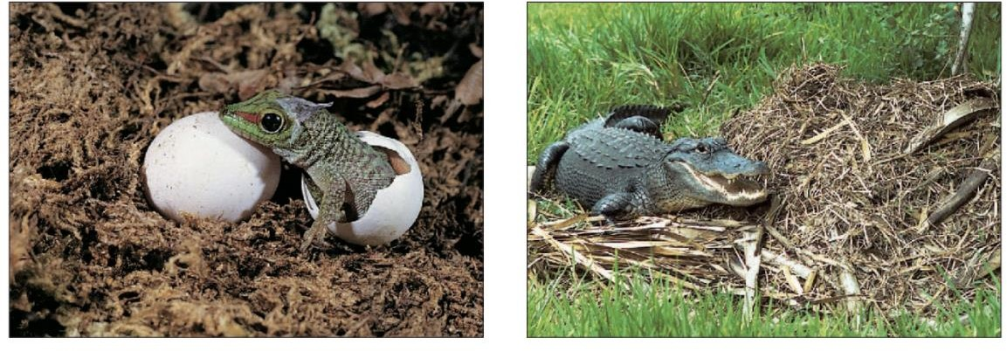
- (b)
Figure 6: a) This young giant Madagascar day gecko (Phelsuma madagascariensis) is hatching from its egg b) A female American alligator (Alligator mis-sissippiensis) tending to her nest.

Further phylogenetic considerations
The archosaur and synapsid lineages of ancient reptiles diverged from ancient amniotes about 280 million years ago and are ancestral to animals described in chapters 21 and 22 (see figure 20.3). The archosaur lineage not only included the dinosaurs and gave rise to crocodilians, but it also gave rise to two groups of fliers. The pterosaurs (Gr. pteros, wing sauros, lizard) ranged from sparrow size to animals with wingspans of 13 m. An elongation of the fourth finger supported their membranous wings, their sternum was adapted for the attachment of flight muscles, and their
bones were hollow to lighten the skeleton for flight. As presented in chapter 21, these adaptations are paralleled by, though not identical to, adaptations in the birds—the descendants of the second lineage of flying archosaurs. The synapsid lineage eventually gave rise to the mammals. The legs of synapsids were relatively long and held their bodies off the ground. Teeth and jaws were adapted for effective chewing and tearing. Additional bones were incorporated into the middle ear. These and other mammal-like characteristics developed between the Carboniferous and Triassic periods.The “Evolutionary Perspective” of chapter 22 describes more about the nature of this transition.

